Week 1 – Day 1 -Assignments
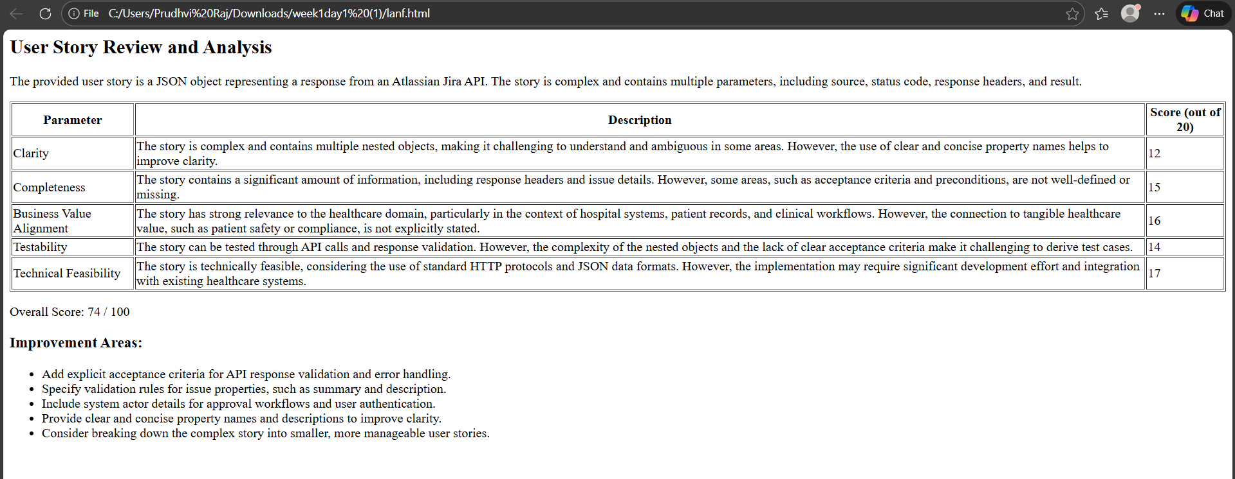
Week1 – Day 2
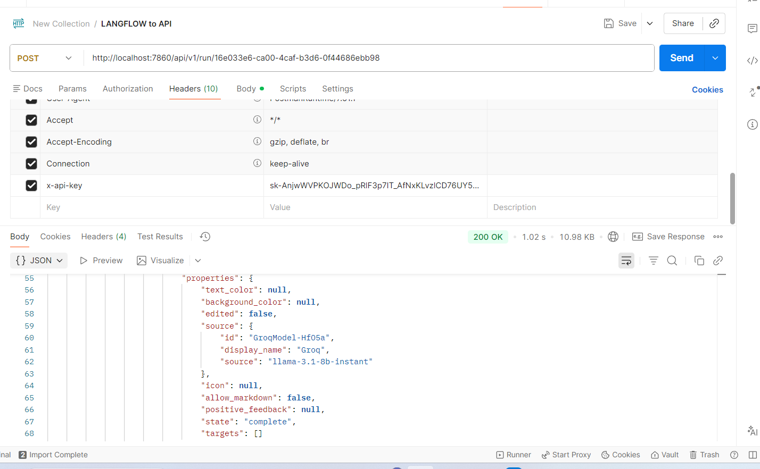
Response :
{
"session_id": "16e033e6-ca00-4caf-b3d6-0f44686ebb98",
"outputs": [
{
"inputs": {
"input_value": "Generate Salesforce login positive testcases"
},
"outputs": [
{
"results": {
"message": {
"text_key": "text",
"data": {
"timestamp": "2026-02-05 18:52:41 UTC",
"sender": "Machine",
"sender_name": "AI",
"session_id": "16e033e6-ca00-4caf-b3d6-0f44686ebb98",
"context_id": "",
"text": "TC_SF_001\nTitle: Successful Salesforce login with valid credentials\nPreconditions: User is on the Salesforce login page\nSteps:\n1. Enter valid username\n2. Enter valid password\n3. Click on the Login button\nExpected Result: User is successfully logged in and redirected to the Salesforce dashboard\n\nTC_SF_002\nTitle: Successful Salesforce login with valid credentials and remember me option\nPreconditions: User is on the Salesforce login page\nSteps:\n1. Enter valid username\n2. Enter valid password\n3. Check the Remember Me checkbox\n4. Click on the Login button\nExpected Result: User is successfully logged in, and the Remember Me option is enabled\n\nTC_SF_003\nTitle: Successful Salesforce login with valid credentials and two-factor authentication\nPreconditions: User is on the Salesforce login page\nSteps:\n1. Enter valid username\n2. Enter valid password\n3. Click on the Next button\n4. Enter valid OTP\n5. Click on the Verify button\nExpected Result: User is successfully logged in and redirected to the Salesforce dashboard\n\nTC_SF_004\nTitle: Successful Salesforce login with valid credentials and account lockout policy\nPreconditions: User is on the Salesforce login page\nSteps:\n1. Enter valid username\n2. Enter incorrect password (max attempts reached)\n3. Click on the Login button\nExpected Result: User is locked out and an error message is displayed\n\nTC_SF_005\nTitle: Successful Salesforce login with valid credentials and password reset\nPreconditions: User is on the Salesforce login page\nSteps:\n1. Enter valid username\n2. Click on the Forgot Password link\n3. Enter valid email address\n4. Click on the Reset Password button\n5. Enter new password\n6. Click on the Save button\nExpected Result: User's password is successfully reset, and they can log in with the new password",
"files": [],
"error": false,
"edit": false,
"properties": {
"text_color": null,
"background_color": null,
"edited": false,
"source": {
"id": "GroqModel-HfO5a",
"display_name": "Groq",
"source": "llama-3.1-8b-instant"
},
"icon": null,
"allow_markdown": false,
"positive_feedback": null,
"state": "complete",
"targets": []
},
"category": "message",
"content_blocks": [],
"id": "9a0e6ec1-9af1-4f69-a57f-c950f14e4633",
"flow_id": "16e033e6-ca00-4caf-b3d6-0f44686ebb98",
"duration": null
},
"default_value": "",
"text": "TC_SF_001\nTitle: Successful Salesforce login with valid credentials\nPreconditions: User is on the Salesforce login page\nSteps:\n1. Enter valid username\n2. Enter valid password\n3. Click on the Login button\nExpected Result: User is successfully logged in and redirected to the Salesforce dashboard\n\nTC_SF_002\nTitle: Successful Salesforce login with valid credentials and remember me option\nPreconditions: User is on the Salesforce login page\nSteps:\n1. Enter valid username\n2. Enter valid password\n3. Check the Remember Me checkbox\n4. Click on the Login button\nExpected Result: User is successfully logged in, and the Remember Me option is enabled\n\nTC_SF_003\nTitle: Successful Salesforce login with valid credentials and two-factor authentication\nPreconditions: User is on the Salesforce login page\nSteps:\n1. Enter valid username\n2. Enter valid password\n3. Click on the Next button\n4. Enter valid OTP\n5. Click on the Verify button\nExpected Result: User is successfully logged in and redirected to the Salesforce dashboard\n\nTC_SF_004\nTitle: Successful Salesforce login with valid credentials and account lockout policy\nPreconditions: User is on the Salesforce login page\nSteps:\n1. Enter valid username\n2. Enter incorrect password (max attempts reached)\n3. Click on the Login button\nExpected Result: User is locked out and an error message is displayed\n\nTC_SF_005\nTitle: Successful Salesforce login with valid credentials and password reset\nPreconditions: User is on the Salesforce login page\nSteps:\n1. Enter valid username\n2. Click on the Forgot Password link\n3. Enter valid email address\n4. Click on the Reset Password button\n5. Enter new password\n6. Click on the Save button\nExpected Result: User's password is successfully reset, and they can log in with the new password",
"sender": "Machine",
"sender_name": "AI",
"files": [],
"session_id": "16e033e6-ca00-4caf-b3d6-0f44686ebb98",
"context_id": "",
"timestamp": "2026-02-05T18:52:41+00:00",
"flow_id": "16e033e6-ca00-4caf-b3d6-0f44686ebb98",
"error": false,
"edit": false,
"properties": {
"text_color": null,
"background_color": null,
"edited": false,
"source": {
"id": "GroqModel-HfO5a",
"display_name": "Groq",
"source": "llama-3.1-8b-instant"
},
"icon": null,
"allow_markdown": false,
"positive_feedback": null,
"state": "complete",
"targets": []
},
"category": "message",
"content_blocks": [],
"duration": null
}
},
"artifacts": {
"message": "TC_SF_001\n\nTitle: Successful Salesforce login with valid credentials\n\nPreconditions: User is on the Salesforce login page\n\nSteps:\n\n1. Enter valid username\n\n2. Enter valid password\n\n3. Click on the Login button\n\nExpected Result: User is successfully logged in and redirected to the Salesforce dashboard\n\nTC_SF_002\n\nTitle: Successful Salesforce login with valid credentials and remember me option\n\nPreconditions: User is on the Salesforce login page\n\nSteps:\n\n1. Enter valid username\n\n2. Enter valid password\n\n3. Check the Remember Me checkbox\n\n4. Click on the Login button\n\nExpected Result: User is successfully logged in, and the Remember Me option is enabled\n\nTC_SF_003\n\nTitle: Successful Salesforce login with valid credentials and two-factor authentication\n\nPreconditions: User is on the Salesforce login page\n\nSteps:\n\n1. Enter valid username\n\n2. Enter valid password\n\n3. Click on the Next button\n\n4. Enter valid OTP\n\n5. Click on the Verify button\n\nExpected Result: User is successfully logged in and redirected to the Salesforce dashboard\n\nTC_SF_004\n\nTitle: Successful Salesforce login with valid credentials and account lockout policy\n\nPreconditions: User is on the Salesforce login page\n\nSteps:\n\n1. Enter valid username\n\n2. Enter incorrect password (max attempts reached)\n\n3. Click on the Login button\n\nExpected Result: User is locked out and an error message is displayed\n\nTC_SF_005\n\nTitle: Successful Salesforce login with valid credentials and password reset\n\nPreconditions: User is on the Salesforce login page\n\nSteps:\n\n1. Enter valid username\n\n2. Click on the Forgot Password link\n\n3. Enter valid email address\n\n4. Click on the Reset Password button\n\n5. Enter new password\n\n6. Click on the Save button\n\nExpected Result: User's password is successfully reset, and they can log in with the new password",
"sender": "Machine",
"sender_name": "AI",
"files": [],
"type": "object"
},
"outputs": {
"message": {
"message": "TC_SF_001\nTitle: Successful Salesforce login with valid credentials\nPreconditions: User is on the Salesforce login page\nSteps:\n1. Enter valid username\n2. Enter valid password\n3. Click on the Login button\nExpected Result: User is successfully logged in and redirected to the Salesforce dashboard\n\nTC_SF_002\nTitle: Successful Salesforce login with valid credentials and remember me option\nPreconditions: User is on the Salesforce login page\nSteps:\n1. Enter valid username\n2. Enter valid password\n3. Check the Remember Me checkbox\n4. Click on the Login button\nExpected Result: User is successfully logged in, and the Remember Me option is enabled\n\nTC_SF_003\nTitle: Successful Salesforce login with valid credentials and two-factor authentication\nPreconditions: User is on the Salesforce login page\nSteps:\n1. Enter valid username\n2. Enter valid password\n3. Click on the Next button\n4. Enter valid OTP\n5. Click on the Verify button\nExpected Result: User is successfully logged in and redirected to the Salesforce dashboard\n\nTC_SF_004\nTitle: Successful Salesforce login with valid credentials and account lockout policy\nPreconditions: User is on the Salesforce login page\nSteps:\n1. Enter valid username\n2. Enter incorrect password (max attempts reached)\n3. Click on the Login button\nExpected Result: User is locked out and an error message is displayed\n\nTC_SF_005\nTitle: Successful Salesforce login with valid credentials and password reset\nPreconditions: User is on the Salesforce login page\nSteps:\n1. Enter valid username\n2. Click on the Forgot Password link\n3. Enter valid email address\n4. Click on the Reset Password button\n5. Enter new password\n6. Click on the Save button\nExpected Result: User's password is successfully reset, and they can log in with the new password",
"type": "text"
}
},
"logs": {
"message": []
},
"messages": [
{
"message": "TC_SF_001\n\nTitle: Successful Salesforce login with valid credentials\n\nPreconditions: User is on the Salesforce login page\n\nSteps:\n\n1. Enter valid username\n\n2. Enter valid password\n\n3. Click on the Login button\n\nExpected Result: User is successfully logged in and redirected to the Salesforce dashboard\n\nTC_SF_002\n\nTitle: Successful Salesforce login with valid credentials and remember me option\n\nPreconditions: User is on the Salesforce login page\n\nSteps:\n\n1. Enter valid username\n\n2. Enter valid password\n\n3. Check the Remember Me checkbox\n\n4. Click on the Login button\n\nExpected Result: User is successfully logged in, and the Remember Me option is enabled\n\nTC_SF_003\n\nTitle: Successful Salesforce login with valid credentials and two-factor authentication\n\nPreconditions: User is on the Salesforce login page\n\nSteps:\n\n1. Enter valid username\n\n2. Enter valid password\n\n3. Click on the Next button\n\n4. Enter valid OTP\n\n5. Click on the Verify button\n\nExpected Result: User is successfully logged in and redirected to the Salesforce dashboard\n\nTC_SF_004\n\nTitle: Successful Salesforce login with valid credentials and account lockout policy\n\nPreconditions: User is on the Salesforce login page\n\nSteps:\n\n1. Enter valid username\n\n2. Enter incorrect password (max attempts reached)\n\n3. Click on the Login button\n\nExpected Result: User is locked out and an error message is displayed\n\nTC_SF_005\n\nTitle: Successful Salesforce login with valid credentials and password reset\n\nPreconditions: User is on the Salesforce login page\n\nSteps:\n\n1. Enter valid username\n\n2. Click on the Forgot Password link\n\n3. Enter valid email address\n\n4. Click on the Reset Password button\n\n5. Enter new password\n\n6. Click on the Save button\n\nExpected Result: User's password is successfully reset, and they can log in with the new password",
"sender": "Machine",
"sender_name": "AI",
"session_id": "16e033e6-ca00-4caf-b3d6-0f44686ebb98",
"stream_url": null,
"component_id": "ChatOutput-Dvaar",
"files": [],
"type": "text"
}
],
"timedelta": null,
"duration": null,
"component_display_name": "Chat Output",
"component_id": "ChatOutput-Dvaar",
"used_frozen_result": false
}
]
}
]
}

